Luis Vega

AP Comp. Sci. A

Mr. Munro

1/28/20

12.08 Create Your Own Challenge Exam Assignment

A key part of recursion is known as divide and conquer. Divide and conquer is used to break big problems into smaller pieces in order to solve problems. For example, in order to understand divide and conquer in recursion, you need to think of it kind of like a trip or journey and break it into small steps in order to form the whole. A form of art that can be used to demonstrate the concept of recursion and divide and conquer is the Mondrian art. The Mondrian art (shown below) is art that is made by dividing a part of the whole into a smaller part and continues to do so until a condition is met. A problem that can be used to explain how recursion works is the recursive piecewise functions. In order to find and solve the recursive piecewise function, you need to simplify and solve it into until the base case is met.

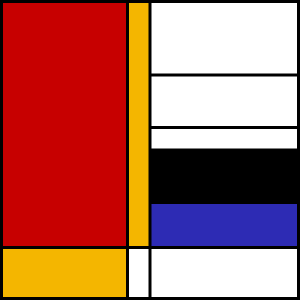

An example of Mondrian art.